Chris Walker
4/7/2015
ENF 111
Multitasking

My understanding and believe that multitasking is not an easy thing to do. There or multiple things that can happen in anyone's life that me make you feel like you are doing more then what you can. There is no way for you to read in English book while trying to write a science paper or trying to your math all the same time more could you do the reading assignment as you're trying to your science experiment good luck. There are multiple ways of multitasking which is one of them is what we do on a daily bases, and rarely people think about it really because it's a natural re-action it’s a natural currents that we feel on a daily basis rather it is walking while talking to a friend, texting while driving, anyone will do homework while talking to our friends on Facebook or twitter. All these are great examples of multitasking which we basically do on daily basis and not one person's ever thought of it being multitasking. Now course with your English, math, science, and social studies. Over the years people been pondering which was even more important than the other, but thanks to Britt and Kate McKay, they created a diagram which helps people make decisions on what some more important than the other.
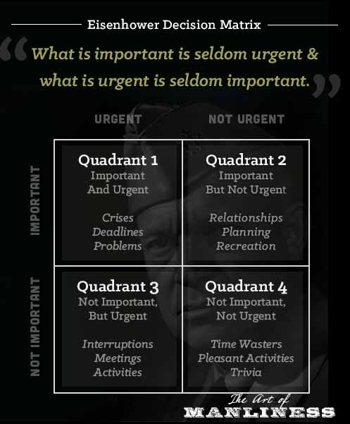

McKay, Brett & Kate McKay made the diagram above, the diagram below is the one that my classmates and I made.

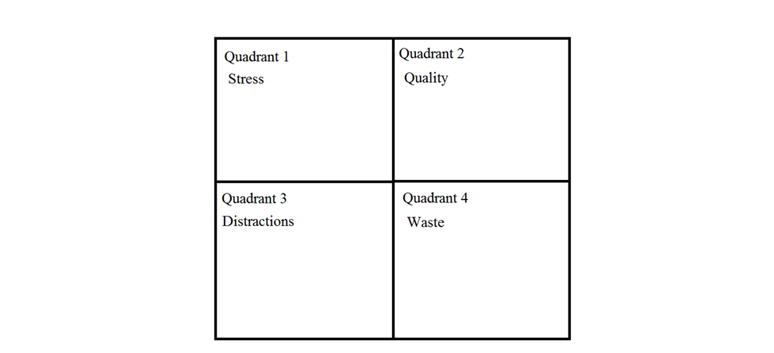

The diagram I made is one that my classmates and I think we understand a coordinates of the diagram made by Britt and Kate McKay and I’m go to summarize a way or try to explain each quadrant as best as I can. Quadrant one Stress if you have too much stress you are going to think right may get some answers wrong and you make decisions that you probably that might be wrong or could be right. So stress is not really good for you you’re trying to overpower you or your work in particular. Quadrant two Quality what can I say about it when it comes to quality it better it’s risible as eligible and you’re able focus on one topic that your teacher or boss had you focus on begin with and what you have at 100% on your mind and your work on it perfectly and clearly it turns out the way you want it and it helps you out in the long run so when it comes like heavy studies ore work he’s probably best be folksonomy 24 seven especially if it’s a big project due price say tomorrow or even a few minutes. If you find quality really hard I see you were to find and one that may take more time to tell your boss her teacher and tell and try to explain to them that you may need more time for you to ask you work on the mayor may not understand but at least they know that you’re trying and you just need some more time to make it look more better. Quadrant three Distractions, when it comes to distractions anything can extract anybody especially equal with ADHD just one small thing can turn them off topic and this everything it’s really easy to get distracted either by playing a game is music on radio or even a TV show is easy to get right up a time but that’s way try to think about quarter to get back to quadrant two quality try doing this is some that’s really important for you like to enjoy it may take a few minutes just to enjoy so take that time to take a break and step away is specimen going to your projects relaxed rate the focus and not stressed out like in quadrant one if you’re stressed out you can do the job right every time. Quarter four Waste their somewhat wastes in the world this one is all about time so call a waste of time there’s times where people or you just want to watch a show or play game more than you want to work and you wind up wasting more time on stuff like playing a game or watching shows. Even though watching shows and playing games is a great deal of relaxing talking with your friends and enjoying your time with them course go syndicator movie with the your boyfriend or girlfriend it’s still nice to actually take the time to stop and do your work in one of failing a lot of subjects that you might want to pass two classes a good get kicked out of your own school. Even though people would rather do nothing at all in the day things would never get done in the world without some form of work in one way or another you want to start waste more time the sooner you get dear work done the more time you have to spend on everything else yes is not a very good idea to spend all your time on your work which is why in some cases Acacia have liked how the homework, I may suggest that you take some time step away from your computer or step away from your work go read a book go watch an episode of two and a get back to take some bigger small down time to refresh and regain your focus.
Work citied

The Eisenhower Decision Matrix: How to Distinguish between Urgent and Important Tasks and Make Real Progress in Your Life (The Art of Manliness) McKay, Brett & Kate McKay <http://www.artofmanliness.com/2013/10/23/eisenhower-decision-matrix/ >

Studies on Multitasking Highlight Value of Self-Control (Education Week) <http://www.edweek.org/ew/articles/2012/05/16/31multitasking_ep.h31.html?tkn=PTWFGpBwR5o7bKrnCvQZswL8Vr%2BlUoJB%2B62c&cmp=clp-edweek>

